**Module 11**

Name: Anandakrishnan k v

Batch id: 30082021

1.Write an LSTM program to predict next alphabet in the sequence “A B C D E F G H I J K L M N O P

Q R S T U V W X Y Z”

Ans:-

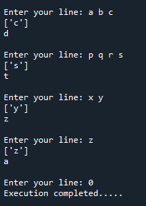

2.Build a LSTM to predict the stock price for multivariate data(use multiple features).Use any online website or tiingo to get the dataset.

Ans:-

